INTERNATIONAL TENNIS TABLE FEDERATION
PARA TABLE TENNIS DIVISION

TECHNICAL DELEGATE REPORT

Name of Tournament: 2017 PTT US OPEN

Ranking Factor Applied for: 40

Name of Responsible Federation: USA TABLE TENNIS FEDERATION

Name of Tournament Organizers: JASNA RATHER

Dates of Play: December 12 – 16, 2017

Name of Technical Delegate: Gorazd Vecko SVN

Report submitted to ITTF PTTD: January 2018

Airport:

McCarran International Airport Las Vegas – around 20 min distance from
the hotels by mini bus, car. The airport consists of four runways and two
passenger terminals: Terminal 1 and Terminal 3. The airport has nonstop air
service to destinations in North America, Europe, and Asia.

Accomodation:

The accommodation was organized in, Harrahs Las Vegas Hotel.
https://www.caesars.com/harrahs-las-vegas
Harrahs Las Vegas is a hotel located on the Las Vegas Strip in Paradise, Las Vegas, Nevada. Theproperty includes a 91,000-square-foot with 2,677 hotel rooms( a lot of them wheelchair accessible). The hotel consists of 2 towers, Mardi Gras and Valley Towers (Formerly named the Carnival Tower), the tallest of which, Valley, has 35 stories.

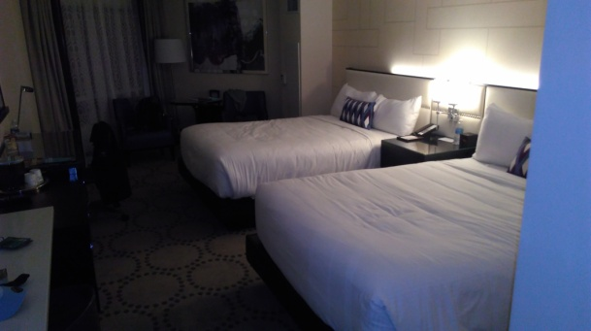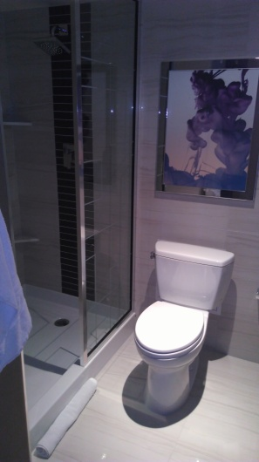

The Harrahs has a Las Vegas Monorail station.

Distance beetwen hotel and venue:

20 minutes totally (10 minutes by monorail and then,
10 min walking distance).

Acreditation:

Accreditation in the venue at the entrance.

Transportation:

The Harrahs has a Las Vegas Monorail station. Participants who paid the full entry
fee received from the organizers free tickets for the Monorail.

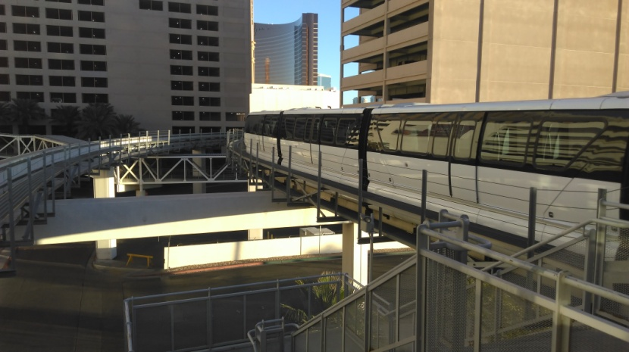 Monorail

Venue:

Las Vegas Convention Center
LVCC 3150 Paradise Road, Las Vegas, NV 89109

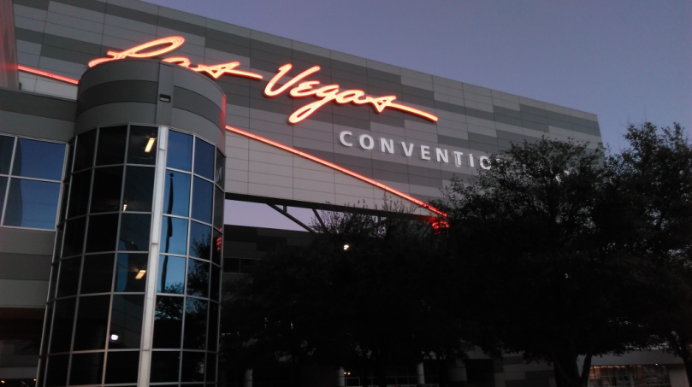

The center is well known for its versatility, size, and amenities. Fully accessible for wheelchair users.

Lighting: Approx. 800 Lux over tables
Referee and TD Table: Close to the playing area in the hall
Call area: Close to the playing area in the hall

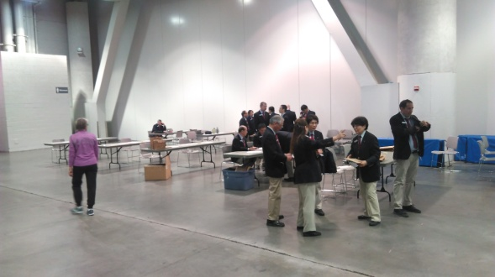 Call area

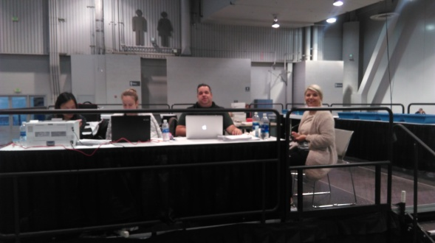 Referee s desk

Equipment:

Tables: 20 tables Joola 3000 SC blue all wheelchair accessible, (10 for standings, 10 for
wheelchairs).
Nets: Joola
Balls: Nittaku*** White (Plastic)
Scoreboards and Umpire’s tables: Joola
Towel boxes: Nittaku
Surrounds: Joola
Floor: Taraflex ( red)

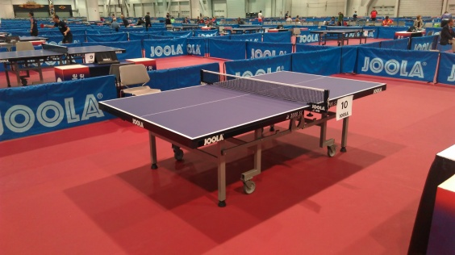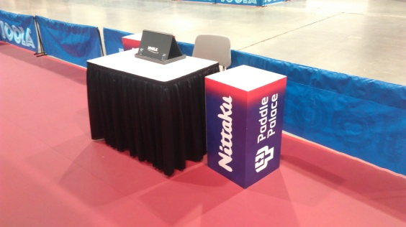

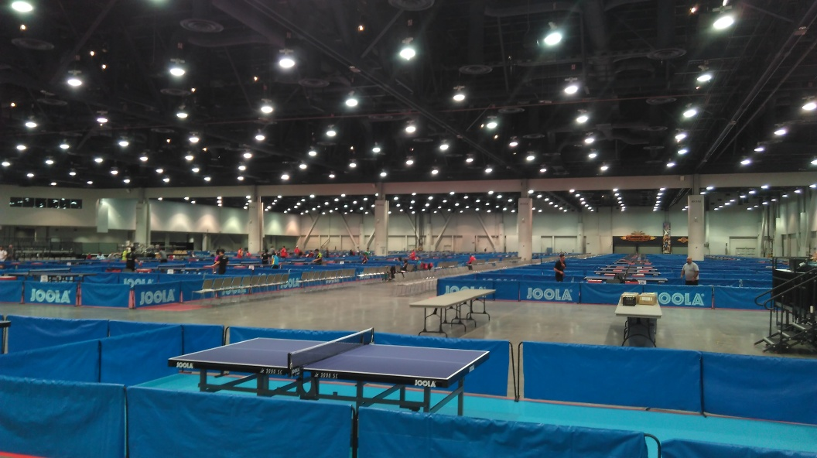

Accesible tables:

Enough wheelchair accessible toilets

Water:

Was in the hall in large water coolers.

Other services:

Computer center, print service and staff were situated at the TD – Referee desk. We somehowe established WI-FI , but just for referee s desk. There was public wi-fi, but outside the playing hall. We also have cable internet.
Reserved area for the ball pickers in a specific area next to the Call Area.

Results Service: A volunteer girls were inputting the results.

Medical service:
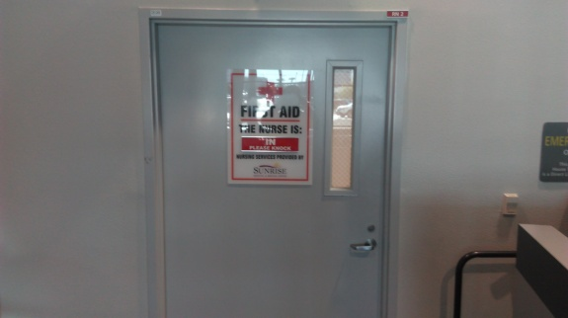

Available everyday throughout the tournament.

Information board:

Close to the playing area in the hall. 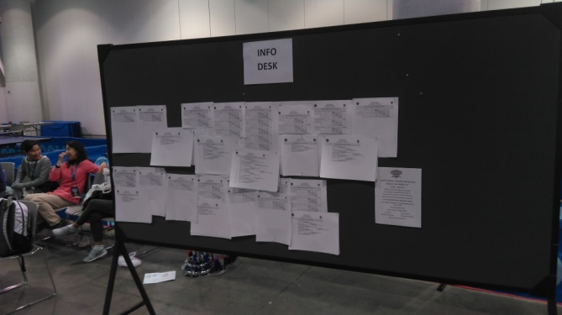

Meals:

All participants got a vouchers for meals at the hotels.

SCHEDULE:

12TH December Arrivals, Draw for Single Event, Technical Meeting
13^{Tth} December Single Event, Draw for Team Event
14TH December Single event and Team Event, Medal ceremony Single Event
15TH December Team Event, Medal ceremony for Team Event
16TH Decenber Departures

Participants USA Open Tournament:

Players from 24 nations were present.

AUT, BRA, CAN, CHI, DEN, ECU, FIN, FRA, GBR, GER, GUY, INA, ISR, ITA, JPN, KEN, KOR, MEX, NED, NOR, PUR, SWE, THA, USA

Male: 81

Female: 19

Staff: 31

Total: 131

Officials:

Technical Delegate: Gorazd Vecko (SVN)

Referee: Francesco Nuzzo (ITA)

Deputy Referee: Deepak SOMARAPU (USA), Kagin Lee (USA)

Classifier: Cintia Marino (ARG)

Umpires:

31 International and National umpires from 6 countries ( 1 COL, 1 GER, 1 MAL, 6 JPN, 13 CAN and 9 USA )

Ball boys/girls: enough, always available

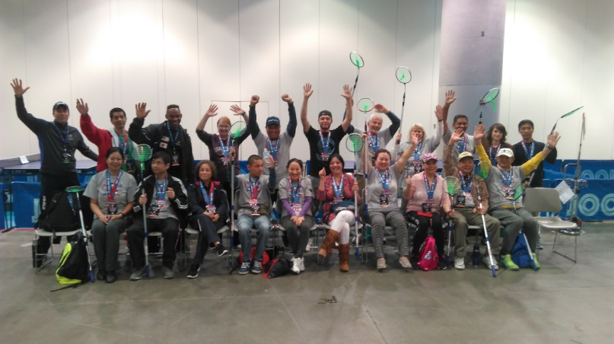

Volunteers: Always very helpful and friendly

Results: During the tournament results were regularly published on the information board
in the playing hall, also updated more than 3 times a day on the IPTTC website.

Articles to ITTF Website:

https://www.ittf.com/2017/12/15/enforced-break-will-bayley-aiming-march-return/

https://www.ittf.com/2017/12/15/worthwhile-journey-gold-david-jacobs-united-states-debut/

https://www.ittf.com/2017/12/15/celebrated-names-beaten-jack-hunter-spivey-shock-winner-las-vegas/

https://www.ittf.com/2017/12/16/success-notable-names-leave-las-vegas-individual-team-titles/

https://www.ittf.com/2017/12/16/destination-las-vegas-eventually-netherlands-arrive/

Ceremonies:

The Medal ceremony for Single Events was held on 14th December at the venue.

The Medal ceremony for Team Events was held in the upper floor of the Convention centre, with some drinks and snacks after the completion of the events.

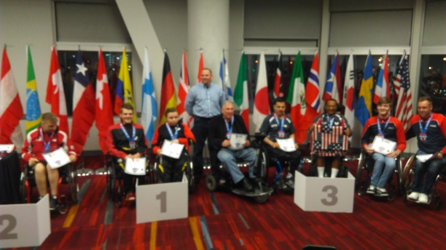

Organizing committee:

Event Manager: Jasna Rather

Technical advisor: Gorazd Vecko

Finance / IT: Teresa Benavides/Gordon Kaye

Results Service: Shu Chen

Support Staff: Daniel Rutenberg

Transportation: Hasibullah Aimaq

Evaluation:

Accommodations: Very Good

Transport: Sufficient

Meals: Very good and big variety

Venue: Very good

Sport equipment: Good, all ITTF approved

Light in the hall: Good

Information: Good, both on the information board and in IPTTC website

Referee Team: Very good

Computer person: Very good

Medal presentation: Good

I take this opportunity to express my sincere thanks to the organizing committee,officials, staffs and volunteers for their great work.
A special thanks to Jasna and her team for their help and support.

